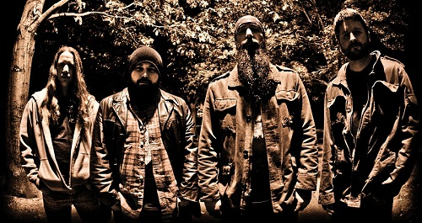
Band: Cortez
Album: Cortez
Label: Bilocation Records
Format: 2LP, download

Release date: April 2012

Lineup:
Matt Harrington: Vocals
Scott O’Dowd: Guitar
Jay Furlo: Bass/Backing vocals
Jeremy Hemond: Drums

Additional personnel:
Chris Coughlin (Cropduster): Hammond
Dana Fisher: Cello
Bio:
If you’re wondering why Massachusetts heavy rockers Cortez would release their first full-length as a double-vinyl, the answer is simple: Balance.

Balance is at the core of everything Cortez does, whether it’s nailing the equal scale measure of pop catchiness and fuzzed-out heavy rock and roll, or in guitarist Scott O’Dowd’s classy lead work and the sense of rocker soul Matt Harrington and bassist Jay Furlo work into the chorus for a song like “Until We Die.” It’s always in balance, always smooth but scuffed up just right. The album’s 11 tracks hit a nerve in reminding what it is about this kind of music that makes us use the term “classic rock,” but the band never sounds redundant or like they’re trying to be someone more than they’re trying to be themselves.

Cortez played their first show in July 2006 and released their debut EP in 2007 on Buzzville Records. Thunder in a Forgotten Town earned the band their first dose of praise both in print and online, and seemed to hit a nerve with the heavy rock underground. The band’s humble sound rung out like riff rock fans dogwhistling their love to other fans, and Cortez toured regionally to support the EP, and continued to play shows and festivals like the Stoner Hands of Doom fest in Maryland, Maine Stoner Fest and WBCN’s Rock ‘n’ Rumble.

But time goes on, and goes quickly. Soon it was three years since the venerated outfit put Thunder in a Forgotten Town to tape at Cambridge’s famous New Alliance Audio (Scissorfight, Cracktorch, etc.), and then four, and now, five. A 2009 demo with new vocalist Matt Harrington showed that Cortez had grown and developed their songwriting to a level of mastery, and live shows proved it was no fluke. The now-foursome, fronted by Harrington, was the most potent incarnation of Cortez yet. The only thing missing was the band’s first full-length.

Between then and now, O’Dowd and drummer Jeremy Hemond vented some frustration in other projects, but there was no question when it was time for Cortez to reemerge, which they did with all the subtlety befitting the conquistador from whom their moniker comes. Recorded once again at New Alliance Audio, engineered and mixed by Ethan Dussault, mastered by Nick Zampiello and Rob Gonella at New Alliance East and boasting artwork by the venerable Alexander von Wieding, Cortez’s Cortez is two LP’s worth of album on two LP’s worth of platters, and it more than makes up for the five years since their last outing.

Cortez were a different band then. Now, they are wiser, stronger, more cohesive and more confident than ever before. And that balance they strike? Yeah, it sits pretty well alongside your Sabbath, your Deep Purple, your Cactus, your Kyuss and your Roadsaw, but it’s also totally their own – and after all this time, they’re just getting started.

www.cortezboston.com • www.facebook.com/cortezboston • www.kozmik-artifactz.com

